Contents
1 SQL Server Health Check 2
1.1 Overview 2
1.2 Target audience 2
1.3 What is a SQL Server Health Check? 2
1.4 Why perform a SQL Server Health Check? 2
1.5 How do I perform a SQL Server Health Check? 3
1.5.1 SQL Server Health Check Flow Chart 3
1.6 SQL Server Health Check Scope 3
1.7 SQL Server Health Check Checklists 3
1.8 SQL Server Health Check Score 4
1.9 Detailed analysis 4
1.9.1 Common findings for all instances 5
1.9.2 Specific findings by instance 8
2 Appendix A 10

SQL Server Health Check

Overview

A SQL Server Health check provides detailed analysis of a SQL Server environment and includes all facets of hardware and software configuration. Our approach is to analyze the total health of your SQL Server environment and highlight areas of concern, providing recommendations to improve the health and performance of your database environment including:

- Database Fragmentation
- Database Integrity Check
- Database Options, File Sizing, File Placement
- Database Recoverability Review
- Maintenance/Backup Job Review
- SQL Server Configuration Options
- SQL Server and Windows Performance Counter Collection
- SQL Server Security Analysis
- Table and Index Analysis

Target audience

Experienced IT staff, responsible for the support, administration and maintenance of a SQL Server environment.

What is a SQL Server Health Check?

A SQL Server Health Check is targeted at assessing the performance, stability and availability of any Microsoft SQL Server based systems.

Essentially, a SQL Server Health Check includes:

- Gathering detailed information about your SQL Servers (in effect, documenting them and creating a baseline of data).
- Comparing collected data to established best practices to identify potential changes to your SQL Servers so that they meet these best practices.
- Examining the differences and determining if the best practices should be implemented, or, because of special circumstances, should be ignored.
- After determining what changes, if any, should be made, test the changes on a test server (in most cases).
- Roll out the changes to production SQL Servers.

From these items, and possibly more, we can establish our SQL Server Health Check goals before we begin to inspect your environment.

Why perform a SQL Server Health Check?

It provides documentation and a baseline for:

- Performance Tuning
- Troubleshooting
- Rebuilding, Disaster Recovery

- To identify potential problems & fix them early.
- To implement best practices (& help develop your own best practices standards guide). This results in performance optimization and higher availability.
- Help to standardize your SQL Server’s configuration throughout your organization.

How do I perform a SQL Server Health Check?

Think of a SQL Server health check similarly to a health check with your physician. On your visit, the doctor will record your basic stats, take a medical history, and perform a number of tests.

In many ways, what the doctor does is to document your health, and then compares what he finds to medical health best practices, to determine your current health.

The next year at your annual check-up, the doctor will examine your again and then compare it to the baseline from the initial checkup. This helps the doctor determine if your health is the same, getting better, or getting worse.

A SQL Server health check is very similar.

SQL Server Health Check Flow Chart



SQL Server Health Check Scope

The scope of this SQL Server health check was limited to the following SQL Server instances:

SRV1 | IP Address
SRV1 | 127.1.1.2
SRV2 | 127.1.1.3
SRV3 | 127.1.1.4
SRV4 | 127.1.1.5
SRV5 | 127.1.1.6
SRV6 | 127.1.1.7

SQL Server Health Check Checklists

This SQL Server health check will cover hundreds of health checklist items and their best practices.
Because it will be impossible to describe each item of the checklist, here is a summary of areas covered by this SQL Server health check:

- Hardware
- Operating System
- SQL Server Settings
- Database Settings
- Security
- Database Maintenance
- SQL Server Agent Jobs
- Log review
- Monitoring
- Performance
- High Availability

SQL Server Health Check Score

The following table includes dashboards that have been created for this SQL Server Health Check.

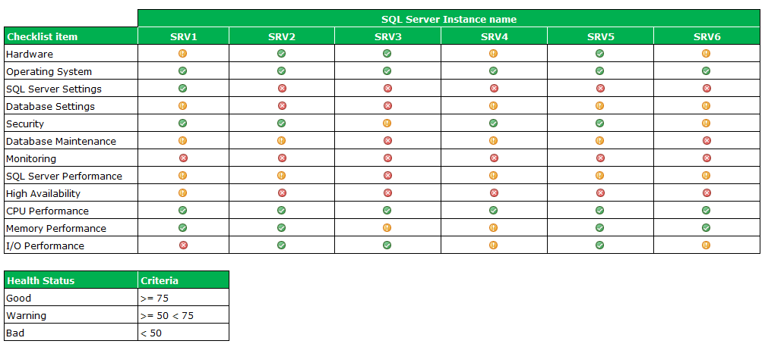

The scorecard metrics from different performance areas mentioned above. Detailed analysis will be provided in the next section.

Detailed analysis

After completion of a Health check data collection and consolidation we moved forward to build a comprehensive report documenting the current status of the SQL Server environment as well as the findings, including recommendations of how to improve the overall health of this environment.

Please check the findings by server below.

Common findings for all instances

Patching

This SQL Server instance has not been patched recently, the last patch applied dates from 2012. According to Microsoft best practices service packs, cumulative updates and security updates must be applied as part of the normal SQL Server maintenance.

These Microsoft patches contains bug fixes, product enhancements and new capabilities that will help the instance to be perform better, reduce vulnerabilities and become very reliable.

VMWare best practices for SQL Server

VMware vSphere contains numerous performance related features that make it easy to virtualize a resource-heavy database with minimal impact to performance. The improved resource management capabilities in vSphere facilitate more effective consolidation of multiple SQL Server virtual machines on a single host without compromising performance or scalability. Greater consolidation can significantly reduce the cost of physical infrastructure and of licensing SQL Server, even in smaller-scale environments.

In 2009, VMware conducted a detailed performance analysis of Microsoft SQL Server 2008 running on vSphere. The performance test placed a significant load on the CPU, memory, storage, and network subsystems. The results demonstrate efficient and highly scalable performance for an enterprise database workload running on a virtual platform.

Lack of SQL Server trace flags for performance

As part of the advantages of having the latest Service packs + cumulative updates is to activate some SQL Server special settings called “trace flags”, these trace flags has the capability to modify some specific SQL Server behaviors or characteristics which are very important in very demanding environments.

List of recommended trace flags:

Trace flag # | Description
8048 | This trace flag partitions certain memory allocators by CPU and can improve performance for highly active servers
1118 | This trace flag reduces TempDB contention
4199 | This trace flag is required to activate all query optimizer fixes
2371 | This trace flag improves the auto update stats algorithm

Lack of Windows configurations for SQL Server

There are two major performance best practices for Windows when hosting a SQL Server instance:

- Database Instant File Initialization

Allows much faster data allocations, this permission keep SQL Server from "zeroing out" new space when you create or expand a data file.

- Lock pages in memory

This setting is useful and has a positive performance impact because it prevents Windows from paging a significant amount of buffer pool memory out of the process, which enables SQL Server to manage the reduction of its own working set.

Wrong SQL Server instance configuration

There are multiple SQL Server instance configurations that must be changed from defaults in order to improve performance and improve stability.

- Max Degree of parallelism

By default, SQL Server will use all available CPUs during query execution. While this is great for large queries, it can cause performance problems and limit concurrency. A better approach
is to limit parallelism to the number of physical cores in a single CPU socket

- Cost Threshold for parallelism

The optimizer uses that cost threshold to figure out when it should start evaluating plans that can use multiple threads. Although there’s no right or wrong number, 5 is a really low setting.

- Backup compression

Make backups smaller, they take less time, and the restores even take less time.

- Remote DAC

By enabling the remote DAC, a DBA can make use of the dedicated administrative connection from any computer that’s allowed to connect to the SQL Server

This is the only way a DBA would connect during cases of serious performance problems.

- Min and Max memory server

By default, SQL Server’s max memory is 2147483647, if the operating system has no memory available, it will start using the page file instead of RAM. Using the page file in place of memory will result in poor system performance.

In order to prevent these kinds of performance issues we must set the MIN and MAX memory settings according the actual SQL Server memory needs.

- Only one data file for TempDB database

SQL Server uses a shared workspace database called TempDB to handle a lot of system tasks (as well as user-created temp tables.) Query operations like joins and aggregations happen there.

On a busy SQL Server having one TempDB datafile can end up waiting a long time to get your “latch” on a system page in TempDB. This can make queries run very slowly in some cases.

As a general rule, if the number of logical processors is less than or equal to 8, use the same number of data files as logical processors. If the number of logical processors is greater than 8, use 8 data files and then if contention continues, increase the number of data files by multiples of 4 (up to the number of logical processors) until the contention is reduced to acceptable levels or make changes to the workload/code.

Wrong database configuration

There are multiple database configurations that must be changed from defaults in order to improve performance and improve stability.

- Percent data growth

Growing database files by a percentage is relatively harmless when databases are small. Once databases grown beyond a few gigabytes, a ten percent file growth can be a cause of performance problems while SQL Server has to wait for space to be allocated.

- Page verification

When SQL Server writes data to disk, it just assumes everything’s fine. It doesn’t periodically patrol the data on disk to see whether it’s good or not.

If databases have page verification set to NONE or TORN_PAGE, SQL Server may not be able to do as good of a job recovering from storage corruption.

- Simple database recovery model

The simple recovery model is generally appropriate for a test or development database. However, for a production database, the best choice is typically the full recovery model, optionally, supplemented by the bulk-logged recovery model.

- MSDB history

SQL Server tracks the history of every backup performed, also tracks the status of each SQL Agent job and creates a record for any single job execution.

Without regular maintenance, the system tables within MSDB can grow to very large sizes leading to a large overall size and performance issues.

SQL Server provides two system stored procedures to trim the size of the MSDB database.

Lack of high availability

SQL Server provides a full range of technologies that allow organizations to reduce downtime and maintain high levels of availability.

These are the high availability techniques for SQL Server:

- Failover Clustering
- Replication
- Log Shipping
- Database Mirroring (To be removed in a near future).
- Availability groups

Apart from the SRV1 SQL Server cluster we didn’t find any high availability technique replicating data to the DR site.

Availability Groups

Is an enterprise-level high-availability and disaster recovery solution introduced in SQL Server 2012 to enable you to maximize availability for one or more user databases.

This SQL Server high availability technology was introduced in 2012 as the next evolution of database mirroring; database mirroring will be removed in a future version of SQL Server.

AlwaysOn advantages

- Combined HA/DR
- Zero data loss protection
- Failover of multiple databases
- Automatic or manual failover
- Local or shared storage
- Automatic page repair
- Active use of secondary databases
- Enhanced performance

Active use of secondary databases (replicas) is probably the most interesting feature AlwaysOn offer, because it can offload some of these read-only and maintenance tasks to the secondary replicas, so the performance of the primary replica will be enhanced.

Because some of the maintenance tasks can consume a great amount of resources, offloading them will optimize the performance of the primary replica.

Specific findings by instance

SQL Server instance – SRV1

SQL Server version: 11.0.3000.0
Edition: Enterprise edition (64-bit)
Product level: SP1
Collation: SQL_Latin1_General_CP1_CI_AS
Logical CPU’s: 32
Physical CPU’s: 2
Physical memory: 64 GBs

Findings

High priority
- The E drive is hosting some SQL Server installation media, these files can be moved to a network shared directory or NAS, instead of using a production server as media repository
- SQL Server Service pack 2 & 3 is not installed
- SQL Server Cumulative update 3 is not installed
- SQL Server performance fixes by trace flags are not enabled
- A new approach is needed to replace the manual index maintenance job
- A new approach is needed to replace the existing table statistics maintenance job
- The Cost threshold for parallelism parameter value is too low
- The Max degree of parallelism parameter value is too low
- There are multiple missing indexes that could be created to improve performance
- Serious disk I\O performance issues, all the Windows LUNs needs to be reviewed
- Slow Storage Reads on Drive F
- Slow Storage Writes on Drive F
- Slow Storage Reads on Drive I
- Slow Storage Reads on Drive W
- Max Data file size is set to a fixed number for INOW6 database. This is a huge risk, if the max value is met the database cannot growth anymore
- Only one data file for TempDB database

Medium priority
- Lock pages in memory is not configured at Windows level
- Database instant initialization is not configured at Windows level
- There are multiple non-used indexes that could be dropped to improve performance
- Windows failover cluster logging is not enabled
- No error log, agent jobs or severe alerts monitoring

Low priority
- The INOW6 database has some data files set to growth by percent
- High number of VLFs (virtual log files) for INOW6 database
- There are no MDSTC mapping between the SQL Server instance and the MSDTC client
- The Windows cluster policies and SQL Server services recovery model needs some changes, they are set to the default
- Replace AlwaysOn for database mirroring
- Add witness server to the current database mirroring configuration

Appendix A

SQL Server patching
https://technet.microsoft.com/en-us/sqlserver/ff803383.aspx

SQL Server trace flags
https://msdn.microsoft.com/en/library/ms188396.aspx
http://social.technet.microsoft.com/wiki/contents/articles/13105.trace-flags-in-sql-server.aspx

Database instance file initialization
https://msdn.microsoft.com/en-us/library/ms175935(v=sql.110).aspx

Lock pages in memory
https://msdn.microsoft.com/en-in/library/ms190730(v=sql.110).aspx

Remote DAC
https://msdn.microsoft.com/en/library/ms190468.aspx

Only one TempDB data file
https://support.microsoft.com/en-us/kb/2154845/

Page Verification
https://msdn.microsoft.com/en-us/library/bb402873.aspx

Simple recovery model
https://technet.microsoft.com/en-us/library/ms175987(v=sql.105).aspx

VMWare best practices for SQL Server
https://www.vmware.com/files/pdf/solutions/SQL_Server_on_VMware-Best_Practices_Guide.pdf

